**EX NO:6 E-TICKETING**

**EDS CHAITANYA(192011372)**

**USE CASE DIAGRAM:**

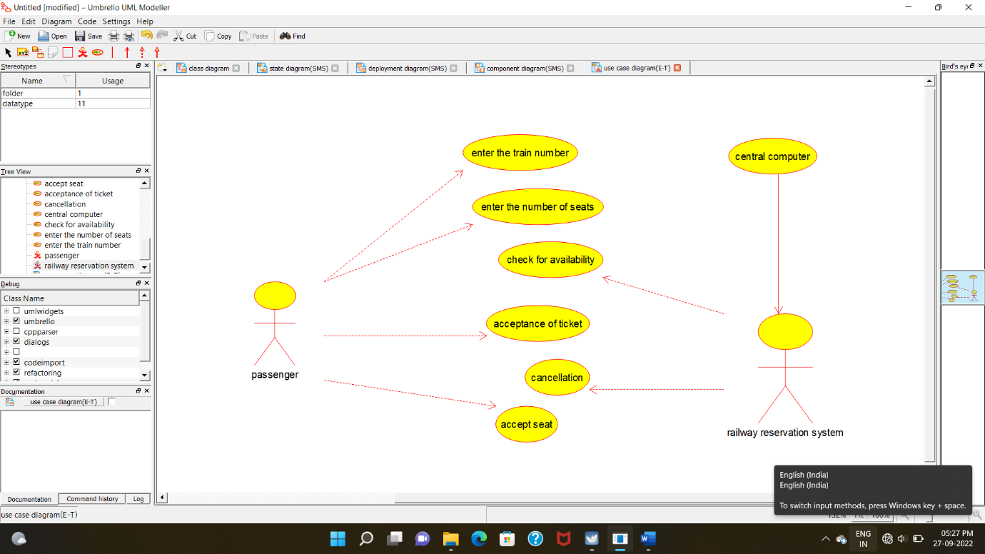

**CLASS DIAGRAM:**

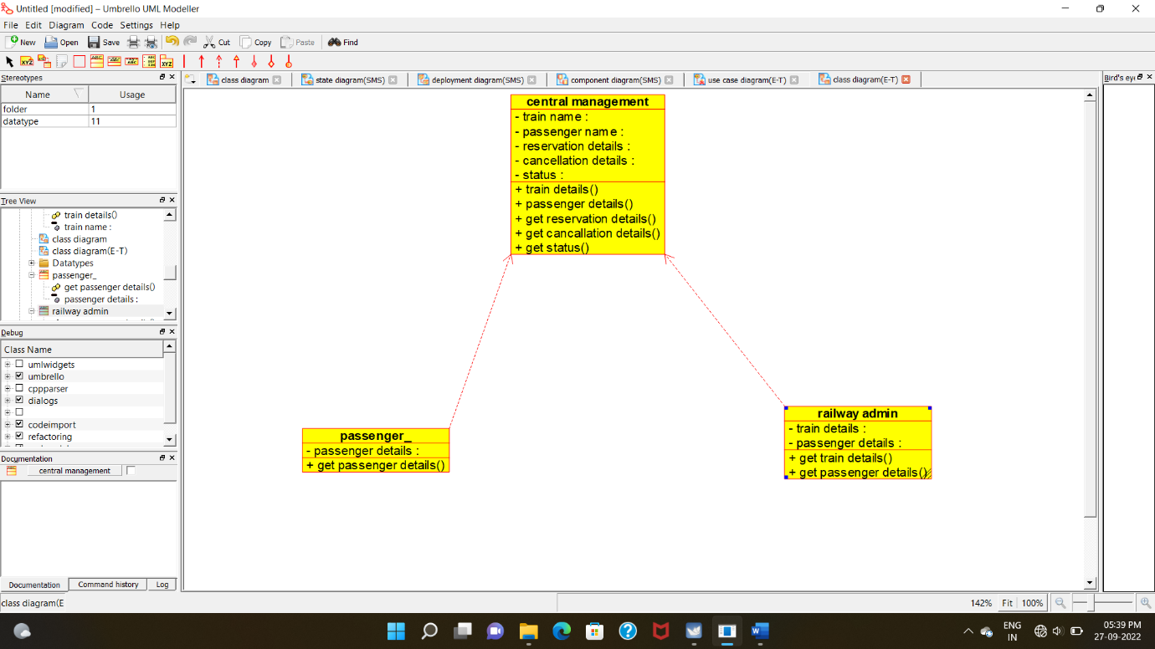

**ACTIVITY DIAGRAM**:

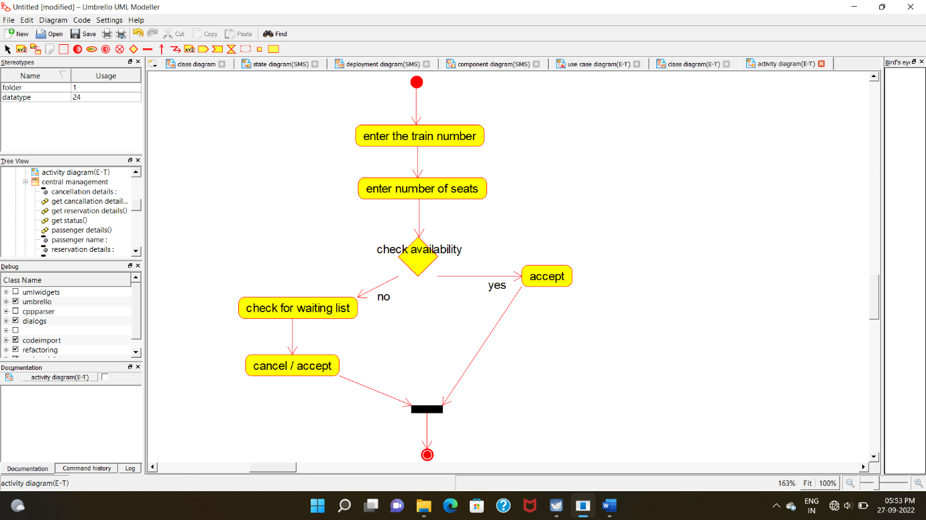

**SEQUENCE DIAGRAM**:

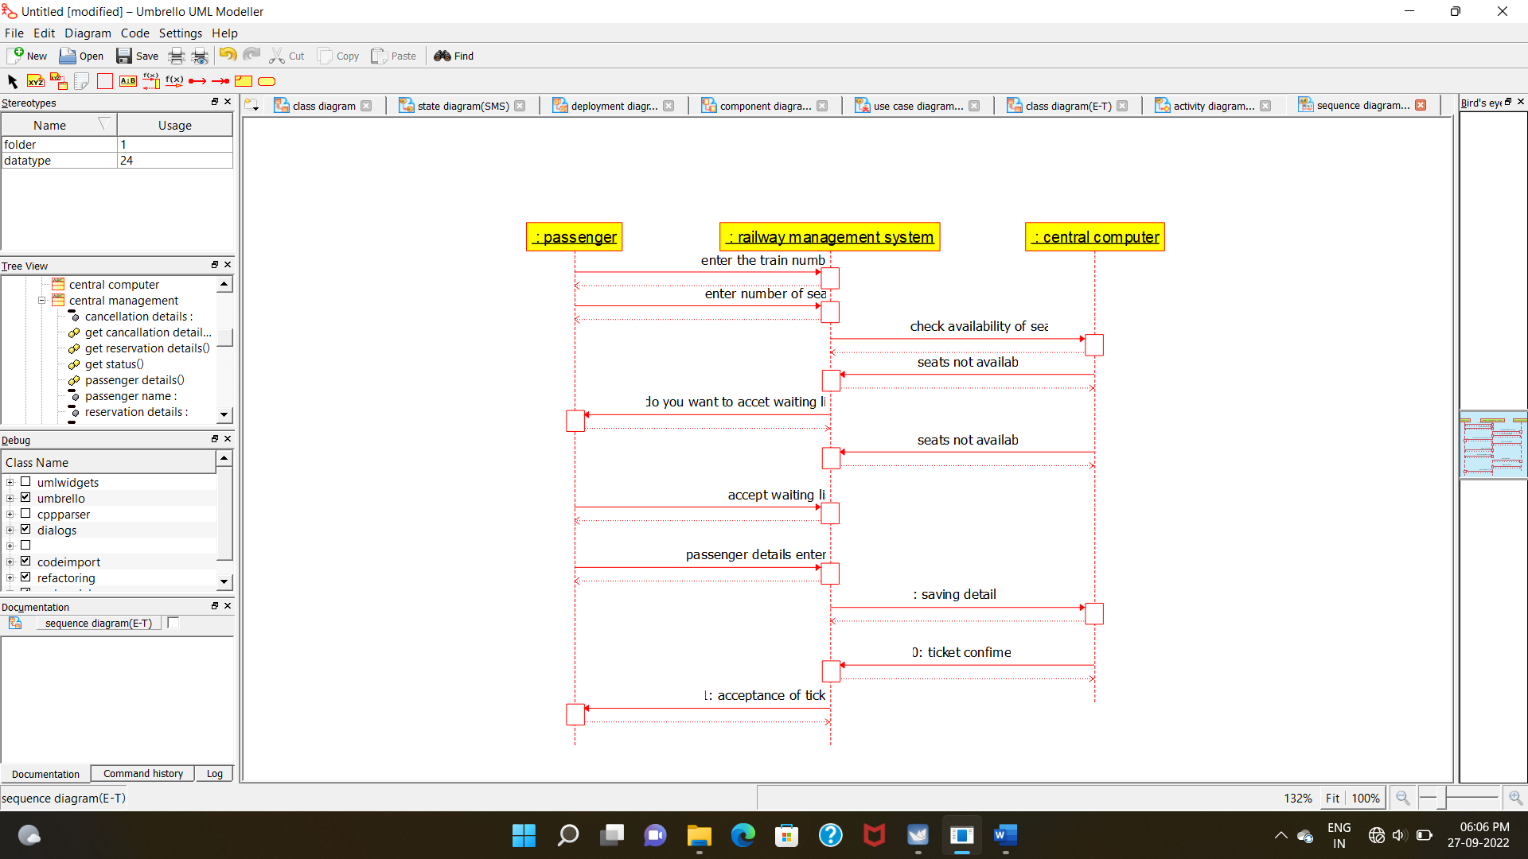

**COLLABORATION DIAGRAM:**

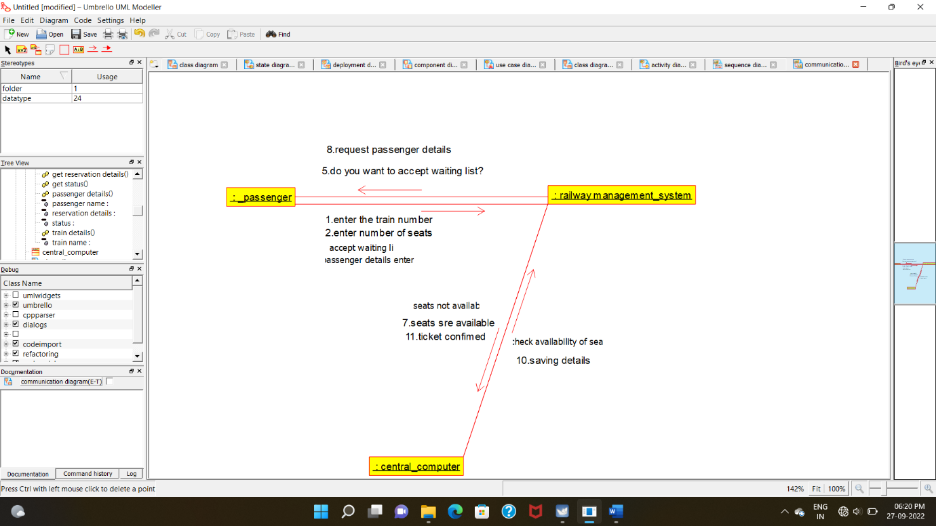

**STATE CHART DIAGRAM:**

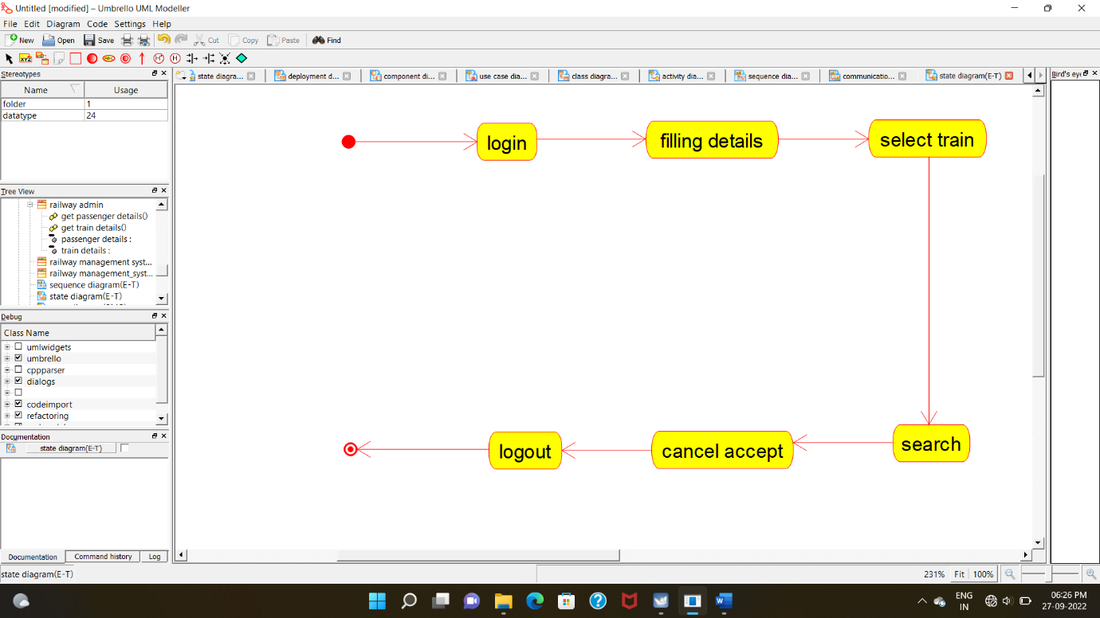

**COMPONENT DIAGRAM:**

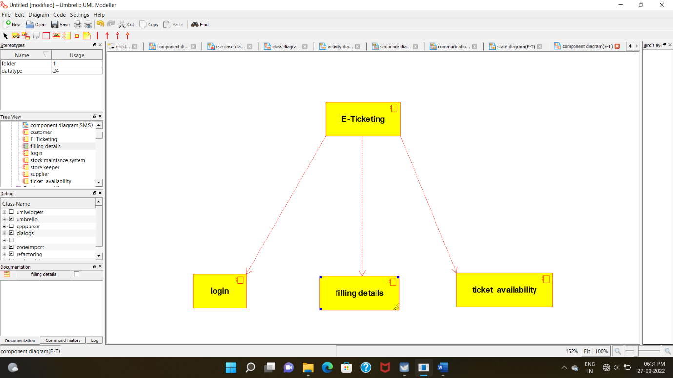

**DEPLOYMENT DIAGRAM:**

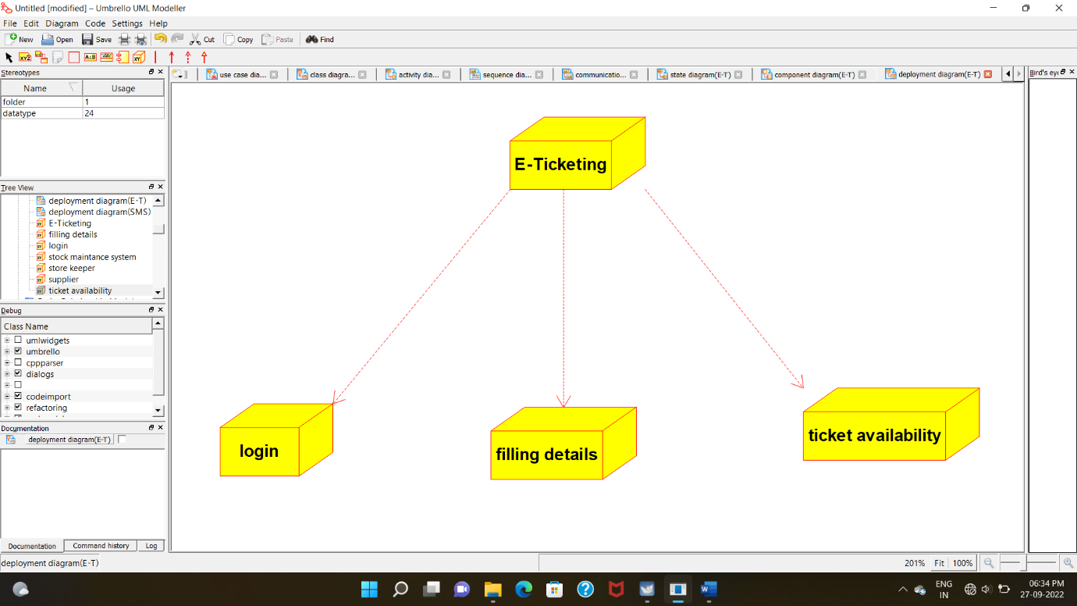

**PACKAGE DIAGRAM:**

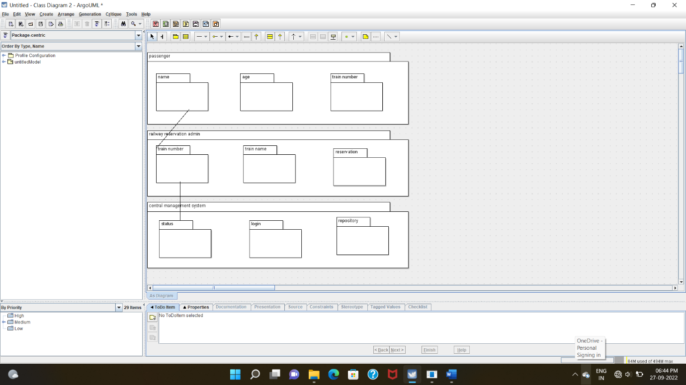

**PROGRAM CODING:**

**PASSENGER:**

/**

* Class passenger_

*/

public class passenger_ {

//

// Fields

//

private void passenger_details;

//

// Constructors

//

public passenger_ () { };

//

// Methods

//

//

// Accessor methods

//

/**

* Set the value of passenger_details

* @param newVar the new value of passenger_details

*/

private void setPassenger_details (void newVar) {

passenger_details = newVar;

}

/**

* Get the value of passenger_details

* @return the value of passenger_details

*/

private void getPassenger_details () {

return passenger_details;

}

//

// Other methods

//

/**

*/

public void get_passenger_details()

{

}

}

**CENTRAL MANAGEMENT SYSTEM:**

/**

* Class central_management

*/

public class central_management {

//

// Fields

//

private void train_name;

private void passenger_name;

private void reservation_details;

private void cancellation_details;

private void status;

//

// Constructors

//

public central_management () { };

//

// Methods

//

//

// Accessor methods

//

/**

* Set the value of train_name

* @param newVar the new value of train_name

*/

private void setTrain_name (void newVar) {

train_name = newVar;

}

/**

* Get the value of train_name

* @return the value of train_name

*/

private void getTrain_name () {

return train_name;

}

/**

* Set the value of passenger_name

* @param newVar the new value of passenger_name

*/

private void setPassenger_name (void newVar) {

passenger_name = newVar;

}

/**

* Get the value of passenger_name

* @return the value of passenger_name

*/

private void getPassenger_name () {

return passenger_name;

}

/**

* Set the value of reservation_details

* @param newVar the new value of reservation_details

*/

private void setReservation_details (void newVar) {

reservation_details = newVar;

}

/**

* Get the value of reservation_details

* @return the value of reservation_details

*/

private void getReservation_details () {

return reservation_details;

}

/**

* Set the value of cancellation_details

* @param newVar the new value of cancellation_details

*/

private void setCancellation_details (void newVar) {

cancellation_details = newVar;

}

/**

* Get the value of cancellation_details

* @return the value of cancellation_details

*/

private void getCancellation_details () {

return cancellation_details;

}

/**

* Set the value of status

* @param newVar the new value of status

*/

private void setStatus (void newVar) {

status = newVar;

}

/**

* Get the value of status

* @return the value of status

*/

private void getStatus () {

return status;

}

//

// Other methods

//

/**

*/

public void train_details()

{

}

/**

*/

public void passenger_details()

{

}

/**

*/

public void get_reservation_details()

{

}

/**

*/

public void get_cancallation_details()

{

}

/**

*/

public void get_status()

{

}

}

**RAILWAY ADMIN:**

/**

* Class railway_admin

*/

public class railway_admin {

//

// Fields

//

private void train_details;

private void passenger_details;

//

// Constructors

//

public railway_admin () { };

//

// Methods

//

//

// Accessor methods

//

/**

* Set the value of train_details

* @param newVar the new value of train_details

*/

private void setTrain_details (void newVar) {

train_details = newVar;

}

/**

* Get the value of train_details

* @return the value of train_details

*/

private void getTrain_details () {

return train_details;

}

/**

* Set the value of passenger_details

* @param newVar the new value of passenger_details

*/

private void setPassenger_details (void newVar) {

passenger_details = newVar;

}

/**

* Get the value of passenger_details

* @return the value of passenger_details

*/

private void getPassenger_details () {

return passenger_details;

}

//

// Other methods

//

/**

*/

public void get_train_details()

{

}

/**

*/

public void get_passenger_details()

{

}

}

**EX:NO:08 SOFTWARE PERSONNEL MANAGEMENT SYSTEM**

**USECASE DIAGRAM:**

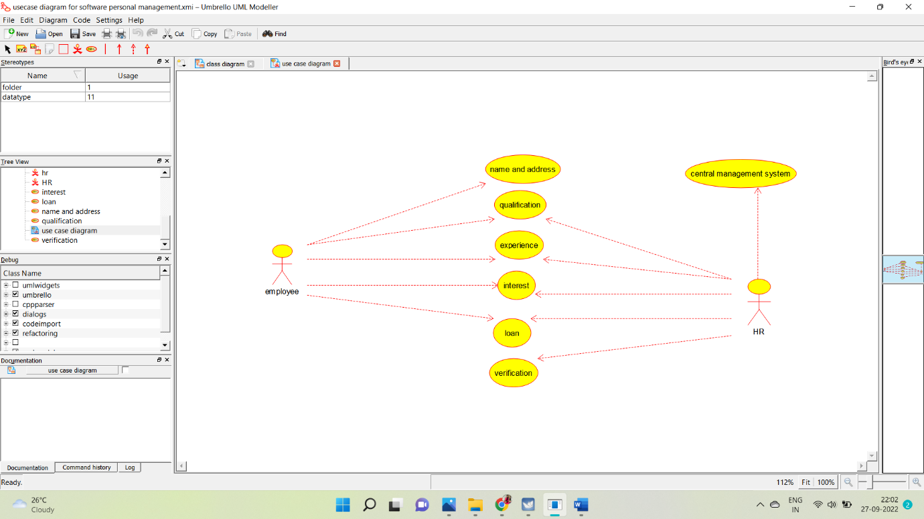

**CLASS DIAGRAM:**

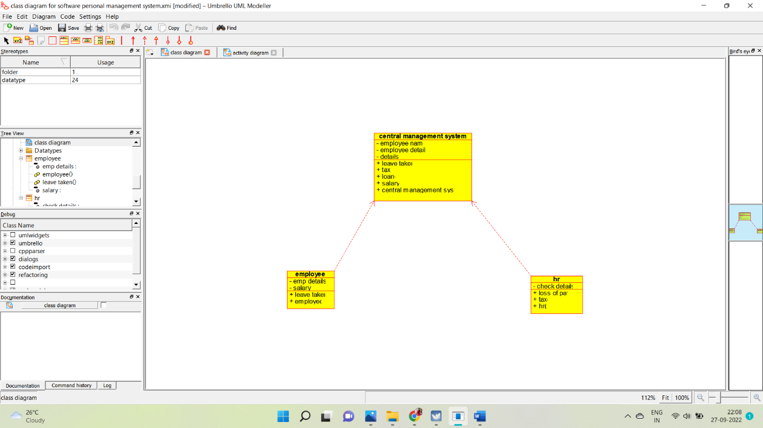

**ACTIVITY DIAGRAM:**

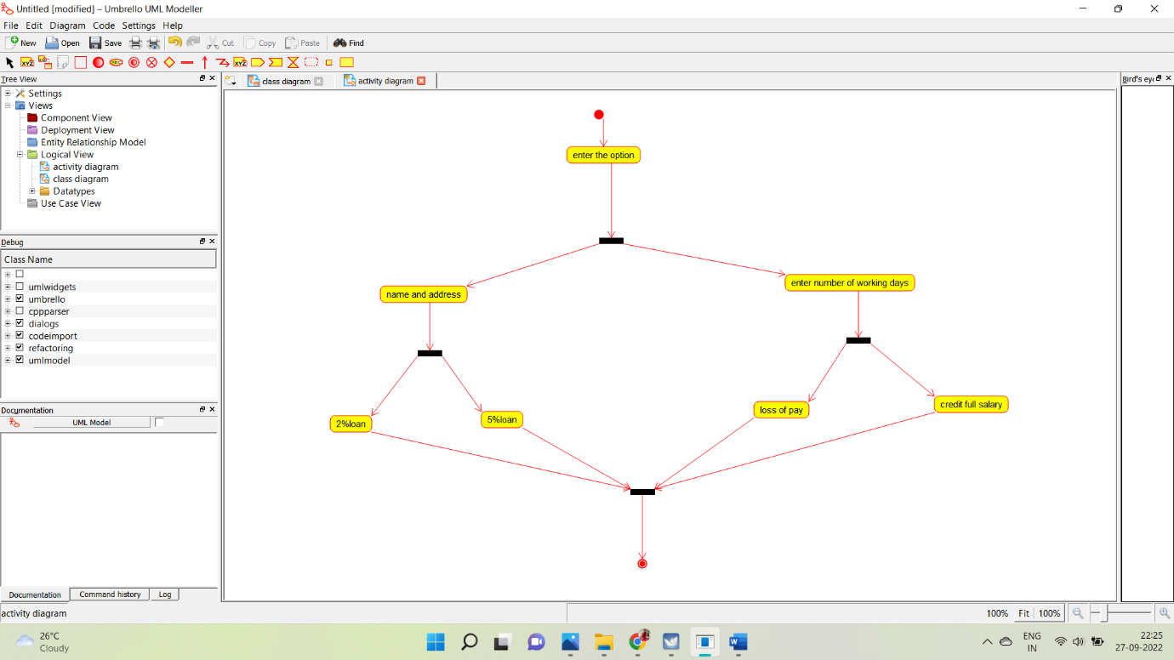

**SEQUENCE DIAGRAM:**

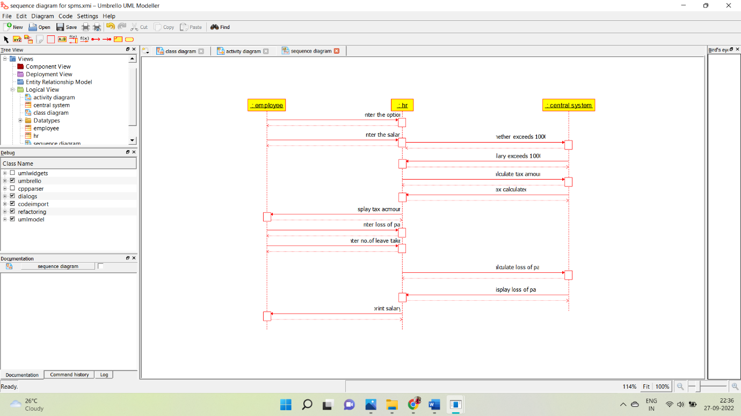

**COLLABORATION DIAGRAM:**

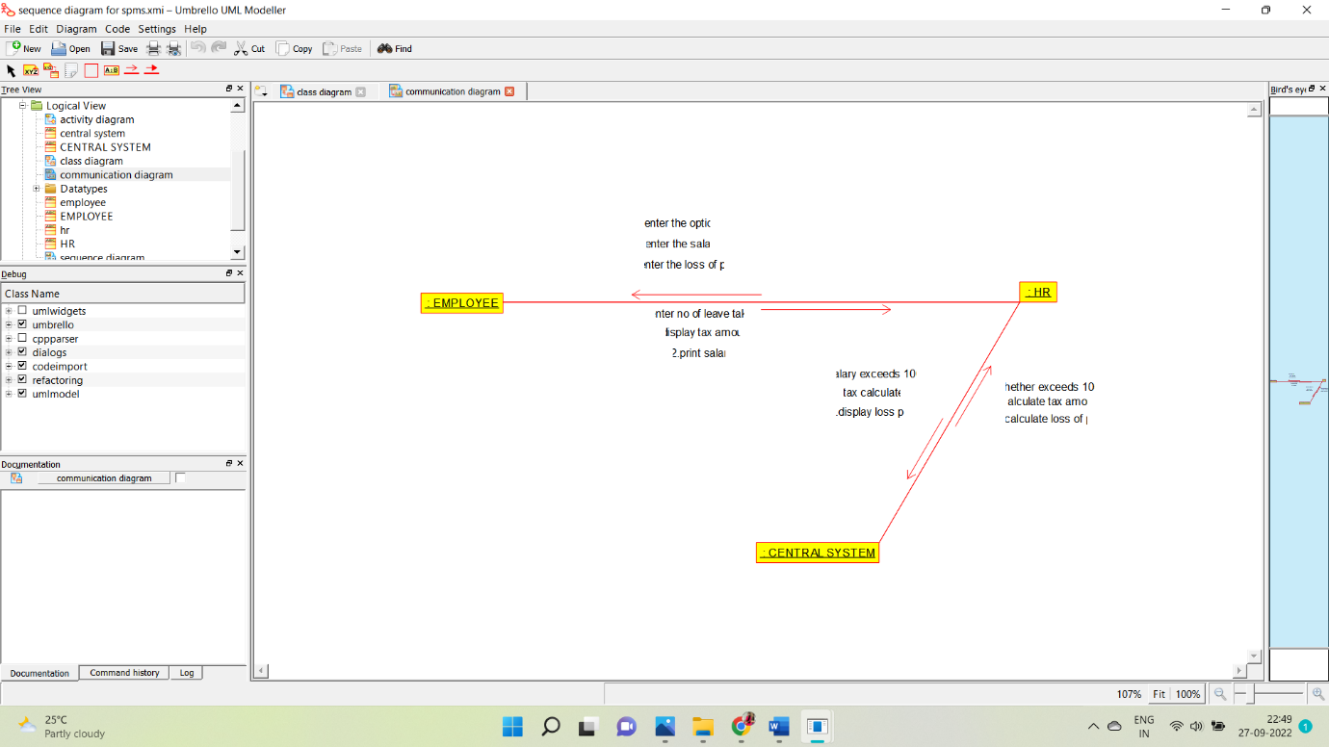

**STATE CHART DIAGRAM:**

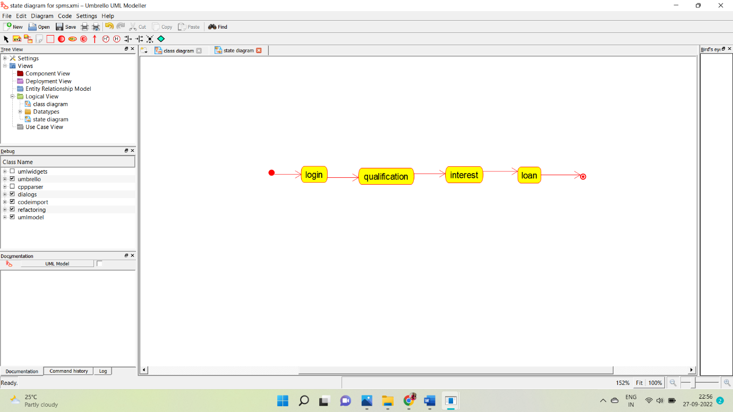

**COMPONENT DIAGRAM:**

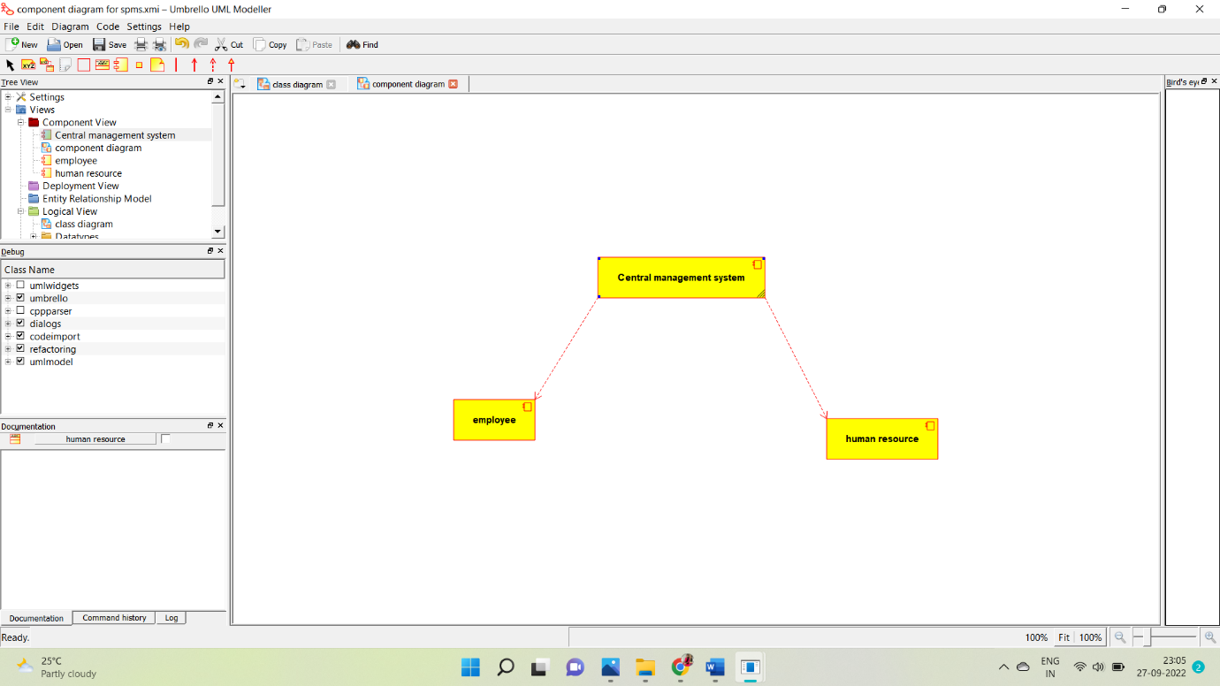

**DEPLOYMENT DIAGRAM:**

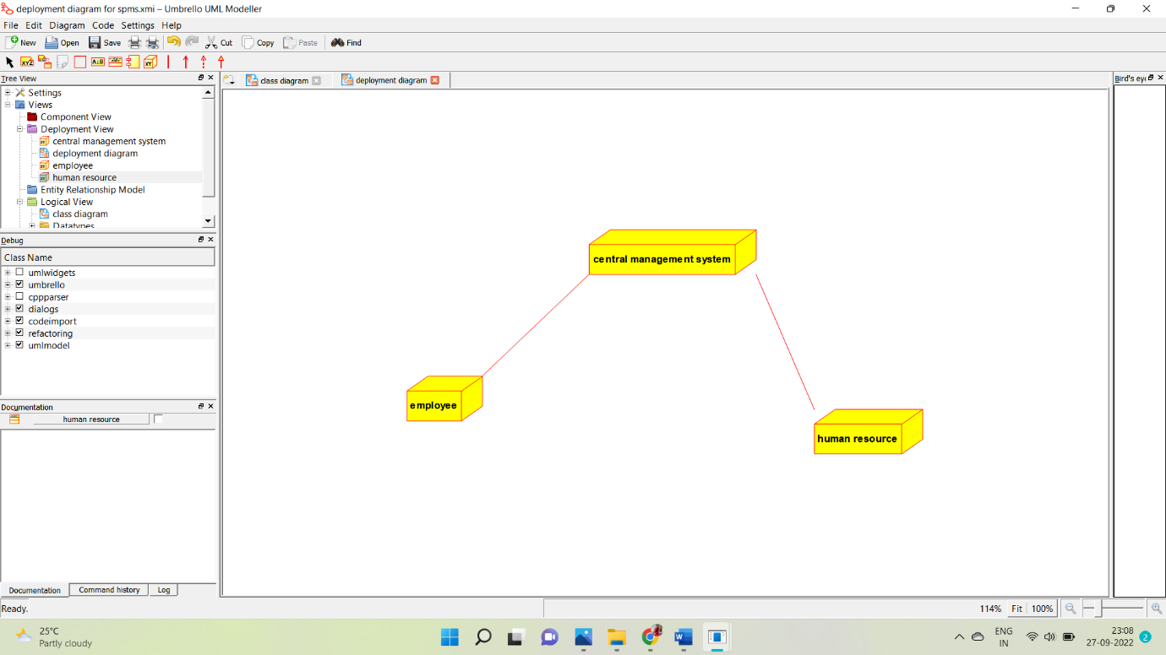

**PROGRAM CODING:**

**EMPLOYEE:**

Public class employee

{

Public integer employee details;

Public integer salary;

Public void leave taken()

{

}

Public void employee()

{

}

}

**HUMAN RESOURCES:**

Public class HR

{

Public integer check details;

Public void loss of pay()

{

}

Public void tax()

{

}

Public void HR()

{

}

}

**CENTRAL MANAGEMENT SYSTEM:**

Public class central management system

{

Public integer employee name;

Public integer employee no;

Public integer details;

Public void leave taken()

{

}

Public void tax()

{

}

Public void loan()

{

}

Public void salary()

{

}

}

**EXP:NO:09 BOOK MANAGEMENT SYSTEM**

**USECASE DIAGRAM:**

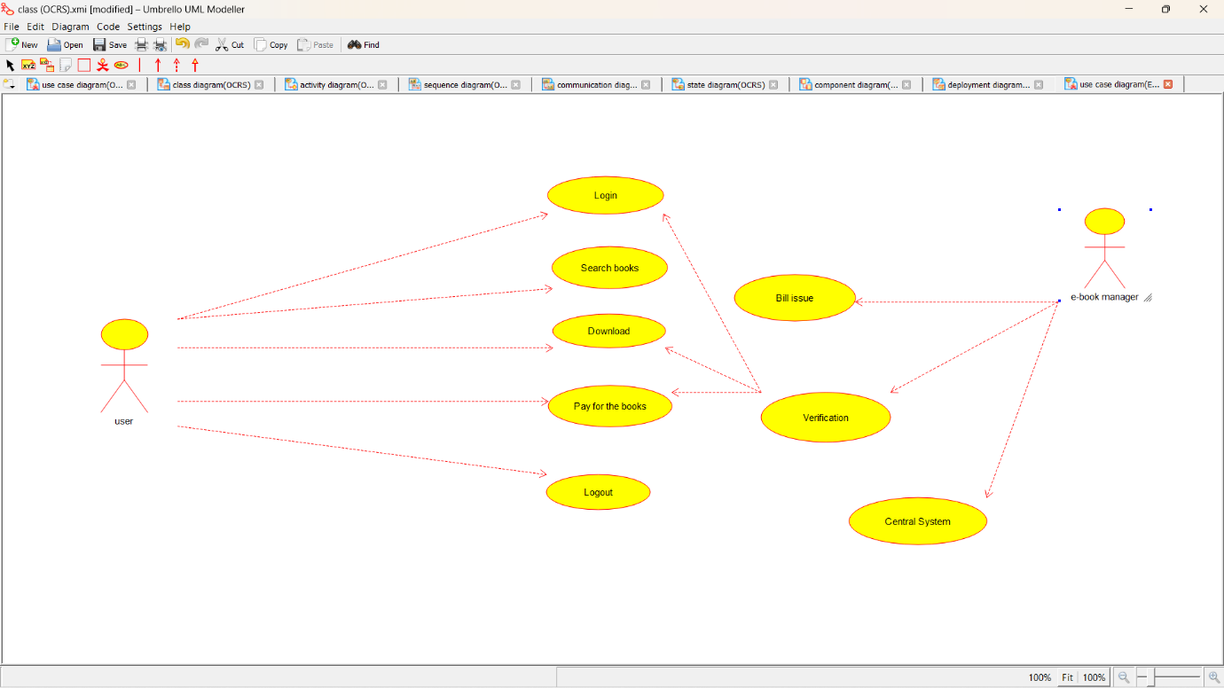

**CLASS DIAGRAM:**

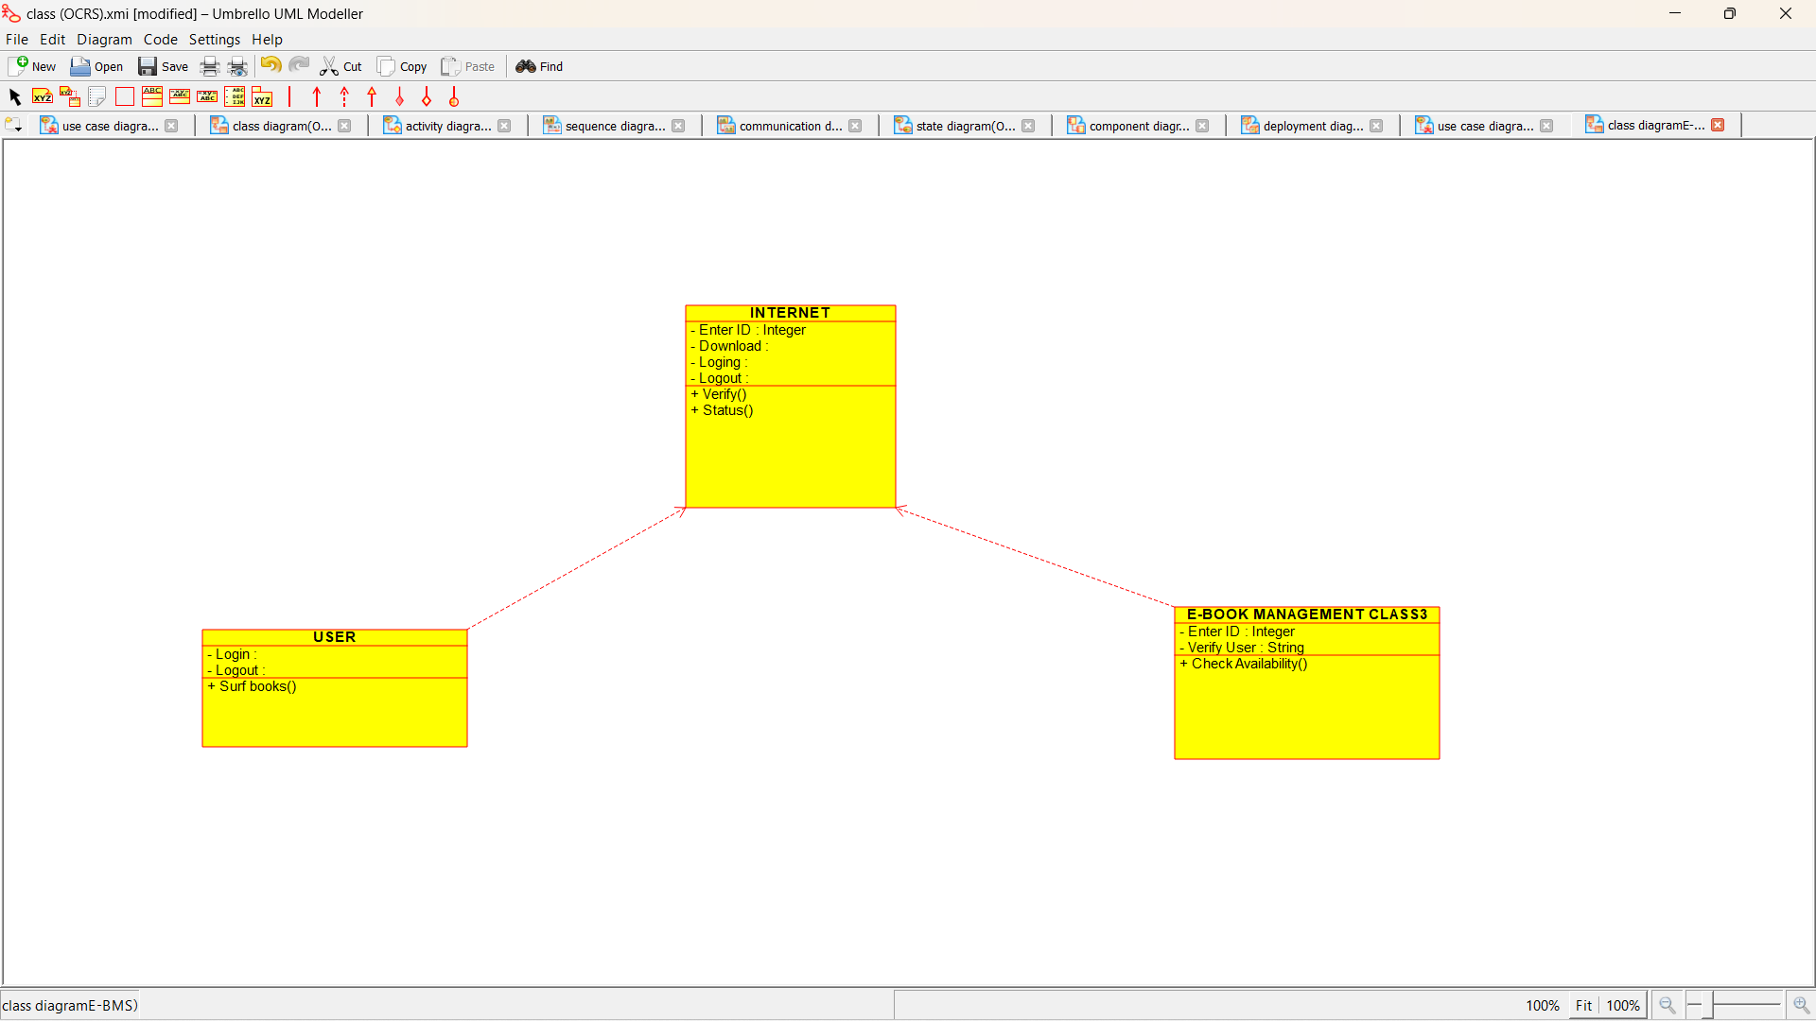

**ACTIVITY DIAGRAM:**

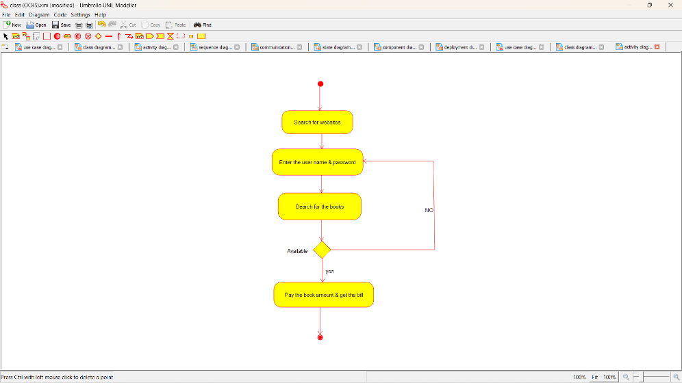

**SEQUENCE DIAGRAM:**

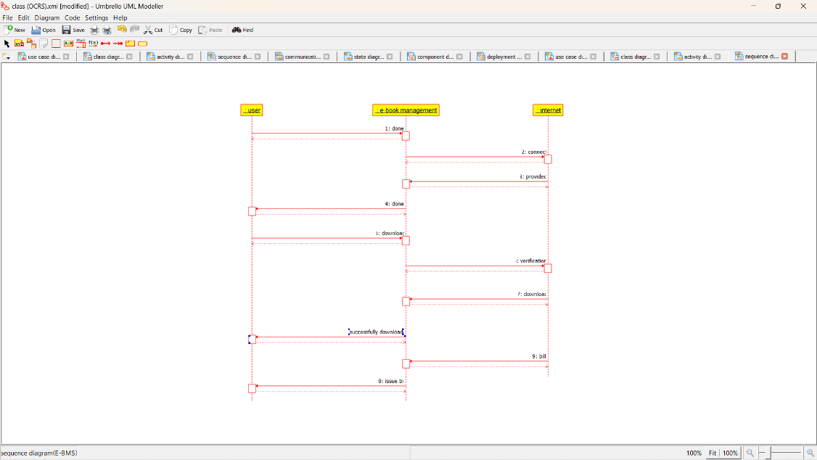

**COLLABORATION DIAGRAM**:

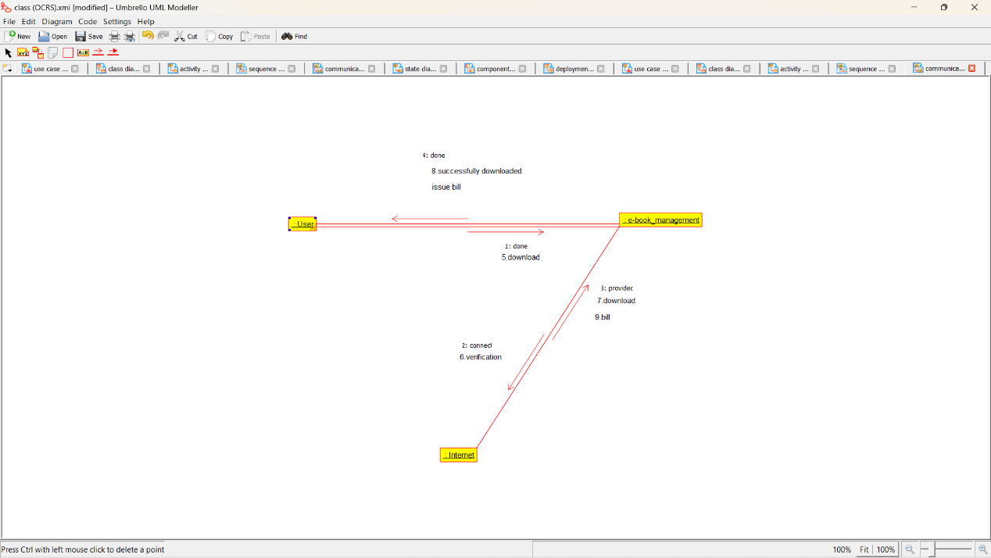

**STATE DIAGRAM:**

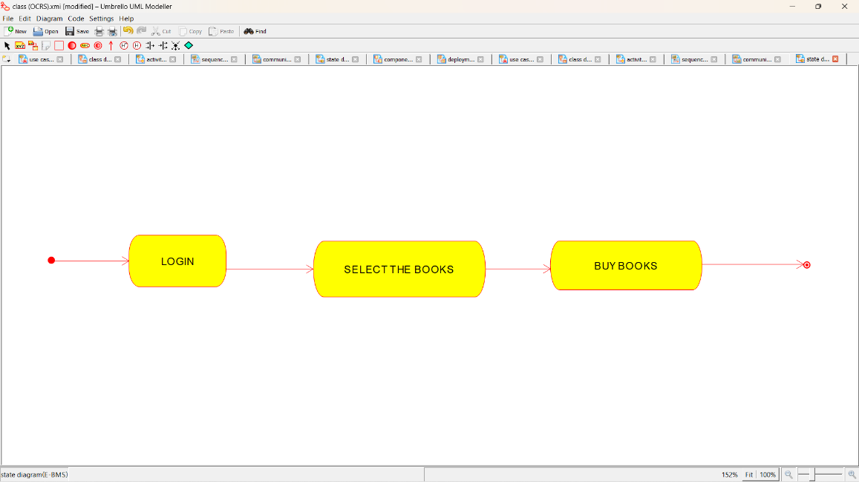

**COMPONENT DIAGRAM**:

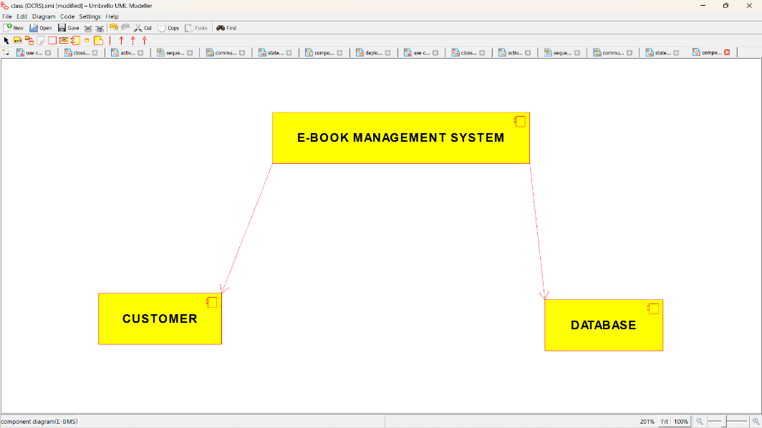

**DEPLOYMENT DIAGRAM:**

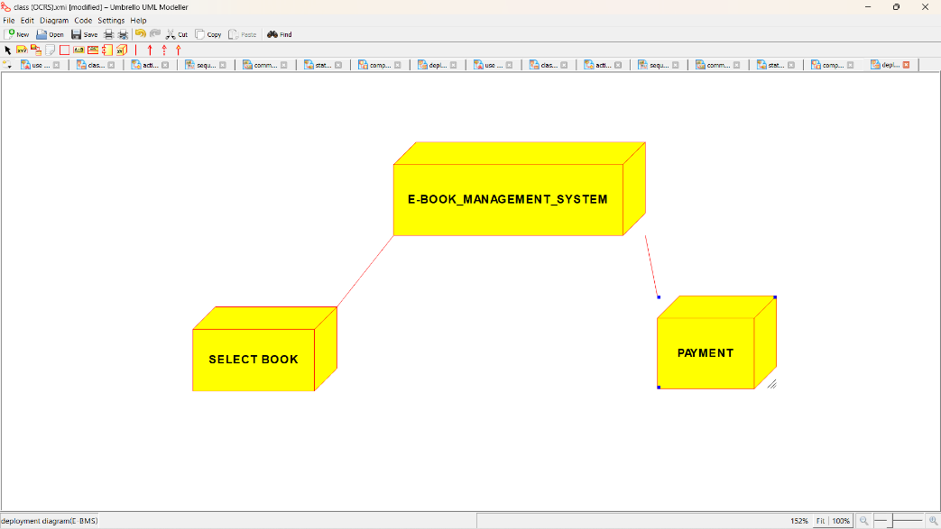

**PROGRAM CODING:**

/**

* Class E_BOOK_MANAGEMENT_CLASS3

*/

public class E_BOOK_MANAGEMENT_CLASS3 {

//

// Fields

//

private Integer Enter_ID;

private String Verify_User;

//

// Constructors

//

public E_BOOK_MANAGEMENT_CLASS3 () { };

//

// Methods

//

//

// Accessor methods

//

/**

* Set the value of Enter_ID

* @param newVar the new value of Enter_ID

*/

private void setEnter_ID (Integer newVar) {

Enter_ID = newVar;

}

/**

* Get the value of Enter_ID

* @return the value of Enter_ID

*/

private Integer getEnter_ID () {

return Enter_ID;

}

/**

* Set the value of Verify_User

* @param newVar the new value of Verify_User

*/

private void setVerify_User (String newVar) {

Verify_User = newVar;

}

/**

* Get the value of Verify_User

* @return the value of Verify_User

*/

private String getVerify_User () {

return Verify_User;

}

//

// Other methods

//

/**

*/

public void Check_Availability()

{

}

}

/**

* Class INTERNET

*/

public class INTERNET {

//

// Fields

//

private Integer Enter_ID;

private void Download;

private void Loging;

private void Logout;

//

// Constructors

//

public INTERNET () { };

//

// Methods

//

//

// Accessor methods

//

/**

* Set the value of Enter_ID

* @param newVar the new value of Enter_ID

*/

private void setEnter_ID (Integer newVar) {

Enter_ID = newVar;

}

/**

* Get the value of Enter_ID

* @return the value of Enter_ID

*/

private Integer getEnter_ID () {

return Enter_ID;

}

/**

* Set the value of Download

* @param newVar the new value of Download

*/

private void setDownload (void newVar) {

Download = newVar;

}

/**

* Get the value of Download

* @return the value of Download

*/

private void getDownload () {

return Download;

}

/**

* Set the value of Loging

* @param newVar the new value of Loging

*/

private void setLoging (void newVar) {

Loging = newVar;

}

/**

* Get the value of Loging

* @return the value of Loging

*/

private void getLoging () {

return Loging;

}

/**

* Set the value of Logout

* @param newVar the new value of Logout

*/

private void setLogout (void newVar) {

Logout = newVar;

}

/**

* Get the value of Logout

* @return the value of Logout

*/

private void getLogout () {

return Logout;

}

//

// Other methods

//

/**

*/

public void Verify()

{

}

/**

*/

public void Status()

{

}

}

/**

* Class USER

*/

public class USER

//

// Fields

//

private void Login;

private void Logout;

//

// Constructors

//

public USER () { };

//

// Methods

//

//

// Accessor methods

//

/**

* Set the value of Login

* @param newVar the new value of Login

*/

private void setLogin (void newVar) {

Login = newVar;

}

/**

* Get the value of Login

* @return the value of Login

*/

private void getLogin () {

return Login;

}

/**

* Set the value of Logout

* @param newVar the new value of Logout

*/

private void setLogout (void newVar) {

Logout = newVar;

}

/**

* Get the value of Logout

* @return the value of Logout

*/

private void getLogout () {

return Logout;

}

//

// Other methods

//

/**

*/

public void Surf_books()

{

}

}

**EX:NO:10 RECRUITMENT SYSTEM**

**USE CASE DIAGRAM:**

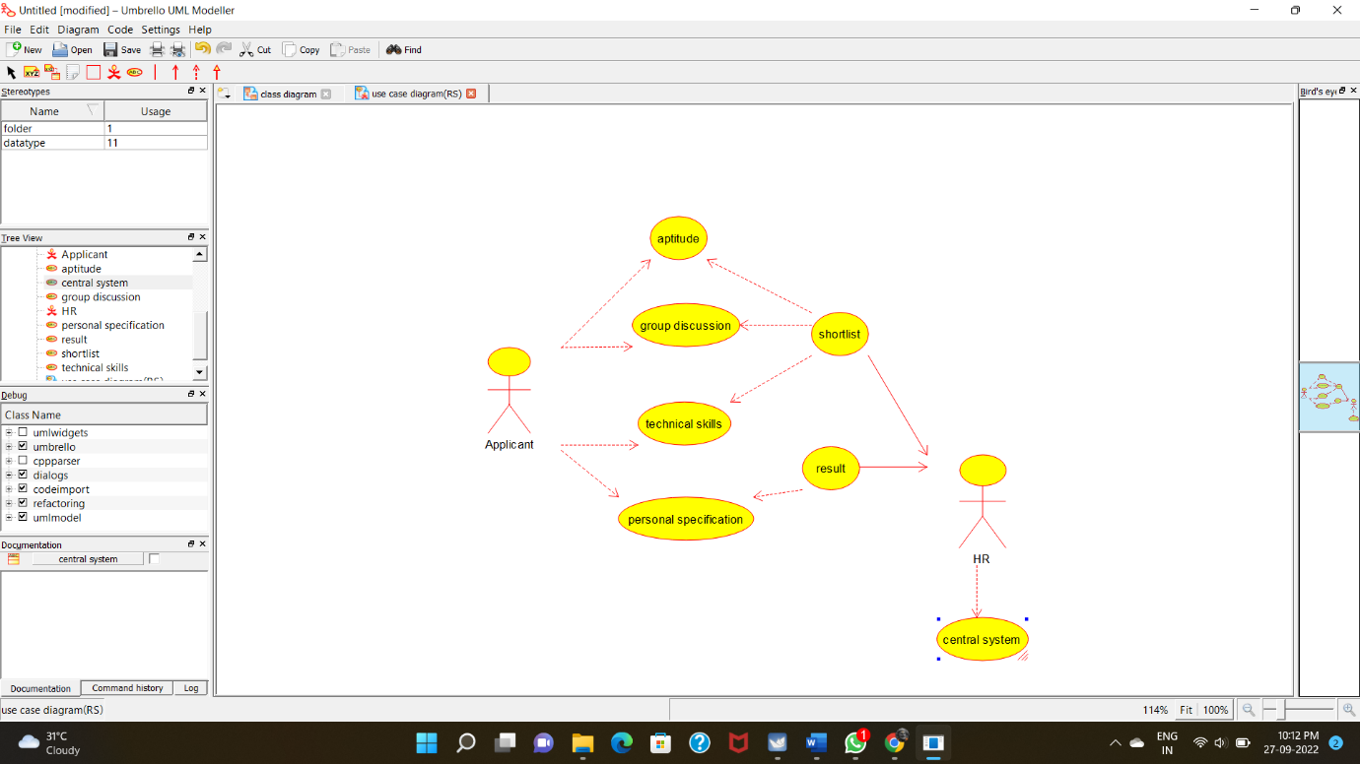

**CLASSDIAGRAM:**

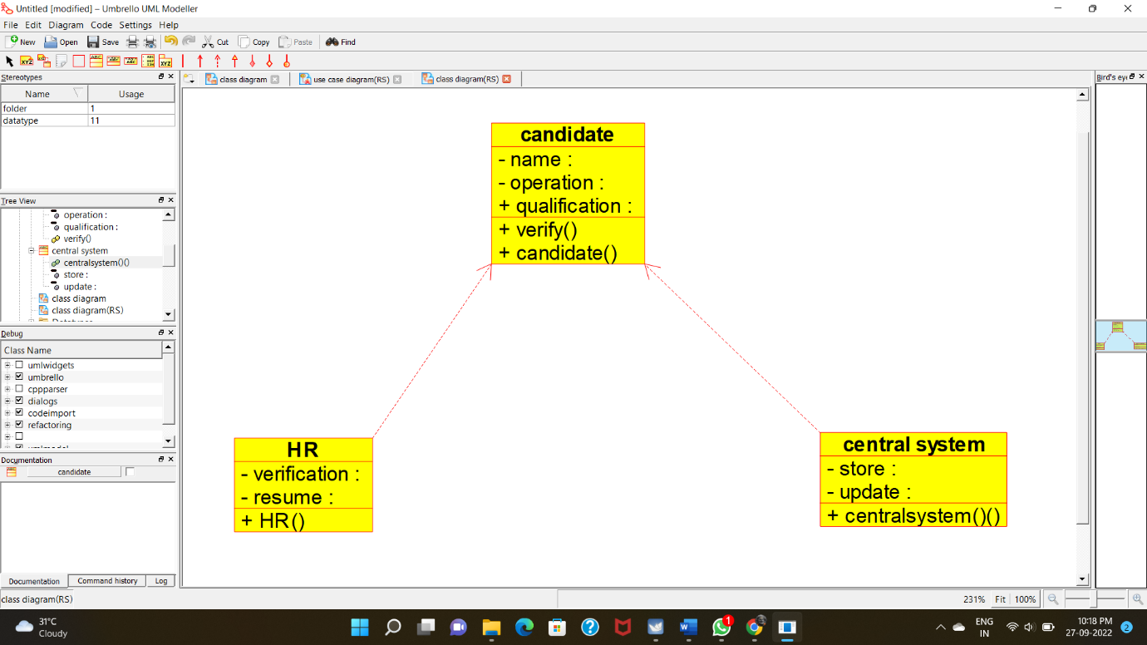

**ACTIVITY DIAGRAM:**

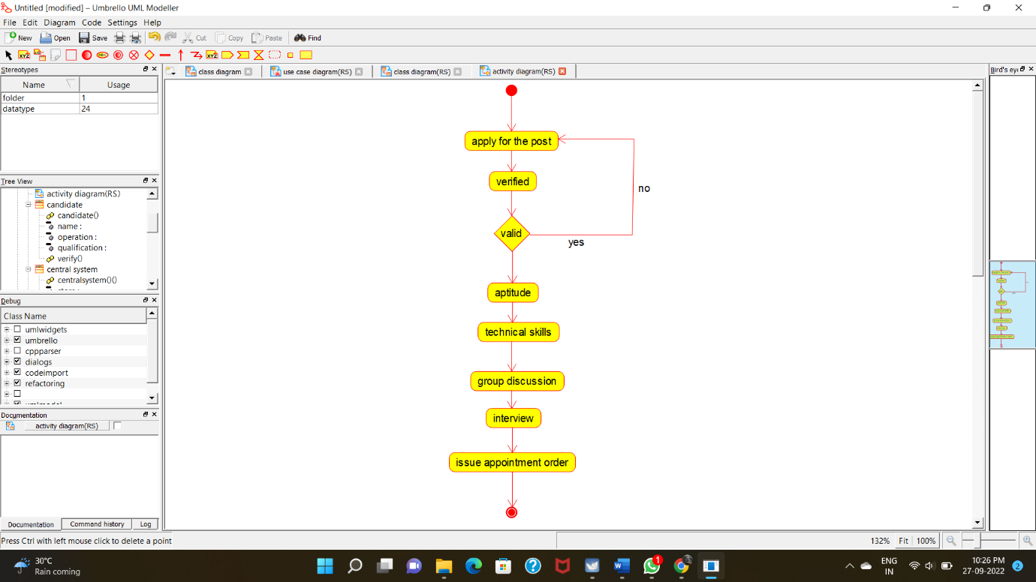

**COLLABORATIONDIAGRAM:**

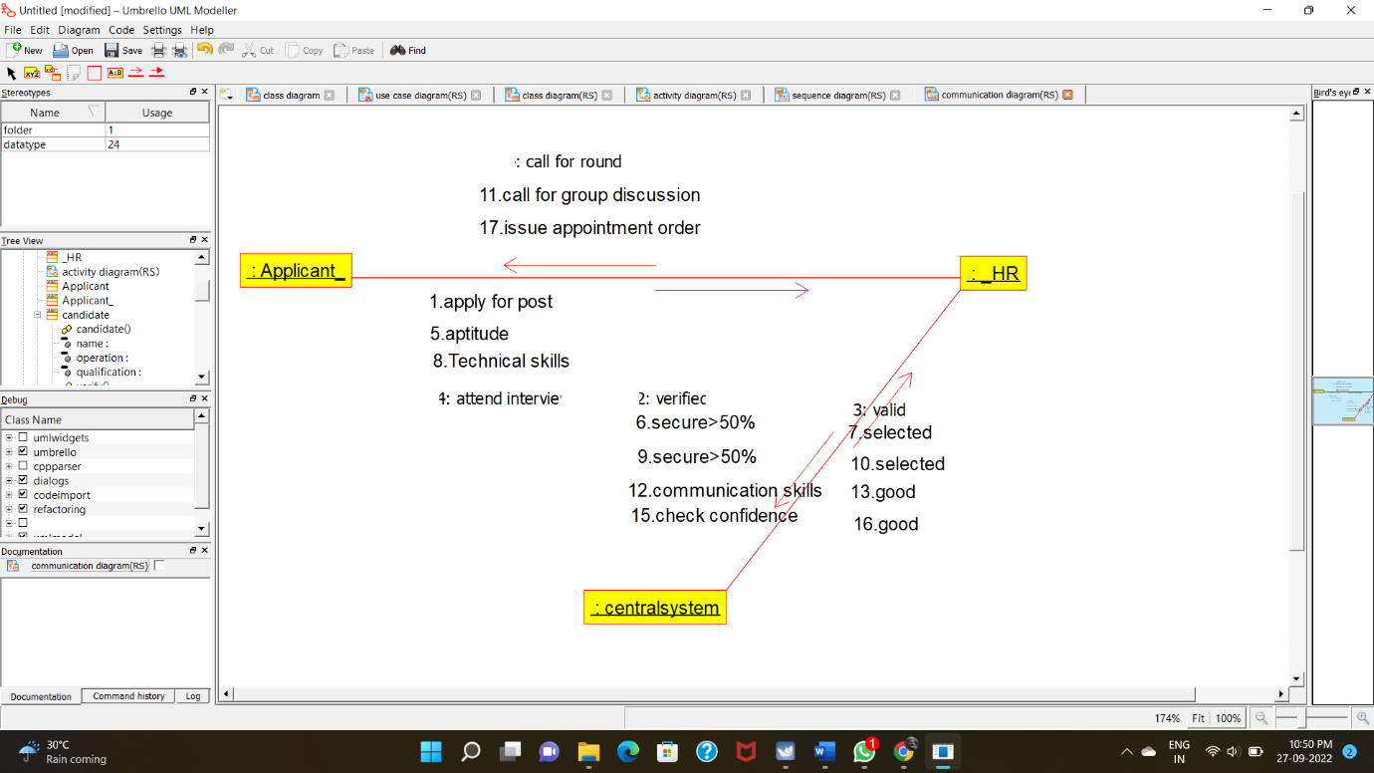

**STATE CHART DIAGRAM:**

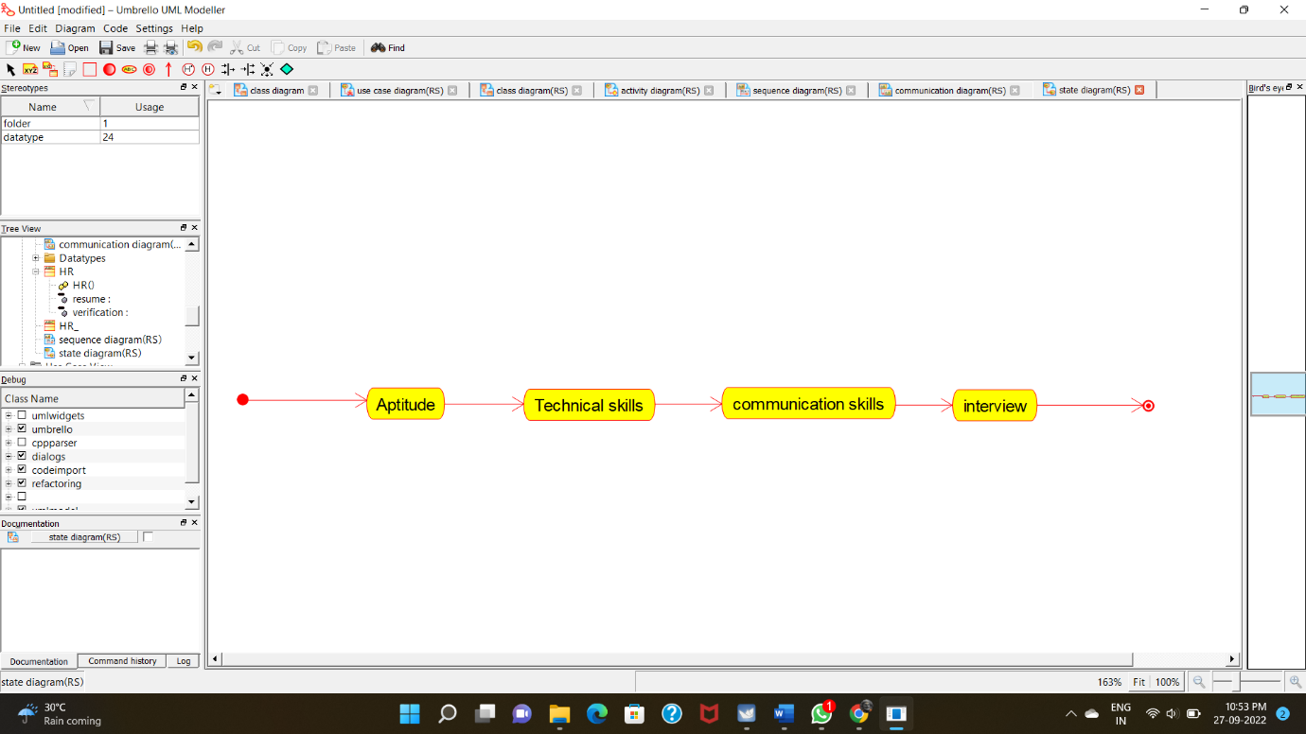

**COMPONENT DIAGRAM:**

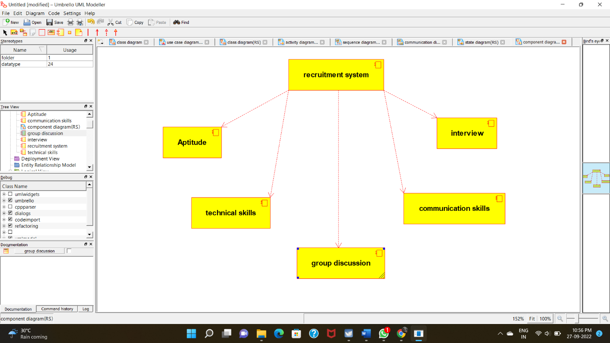

**DEPLOYMENT DIAGRAM:**

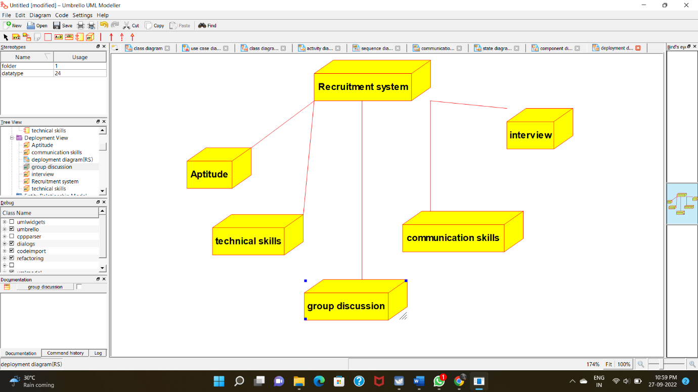

**PROGRAM CODING:**

**CENTRAL SYSTEM:**

**/\*\***

**\* Class central_system**

**\*/**

**public class central_system {**

**//**

**// Fields**

**//**

**private void store;**

**private void update;**

**//**

**// Constructors**

**//**

**public central_system () { };**

**//**

**// Methods**

**//**

**//**

**// Accessor methods**

**//**

**/\*\***

**\* Set the value of store**

**\* @param newVar the new value of store**

**\*/**

**private void setStore (void newVar) {**

**store = newVar;**

**}**

**/\*\***

**\* Get the value of store**

**\* @return the value of store**

**\*/**

**private void getStore () {**

**return store;**

**}**

**/\*\***

**\* Set the value of update**

**\* @param newVar the new value of update**

**\*/**

**private void setUpdate (void newVar) {**

**update = newVar;**

**}**

**/\*\***

**\* Get the value of update**

**\* @return the value of update**

**\*/**

**private void getUpdate () {**

**return update;**

**}**

**//**

**// Other methods**

**//**

**/\*\***

**\*/**

**public void centralsystem_()**

**{**

**}**

**}**

**HR:**

**/\*\***

**\* Class HR**

**\*/**

**public class HR {**

**//**

**// Fields**

**//**

**private void verification;**

**private void resume;**

**//**

**// Constructors**

**//**

**public HR () { };**

**//**

**// Methods**

**//**

**//**

**// Accessor methods**

**//**

**/\*\***

**\* Set the value of verification**

**\* @param newVar the new value of verification**

**\*/**

**private void setVerification (void newVar) {**

**verification = newVar;**

**}**

**/\*\***

**\* Get the value of verification**

**\* @return the value of verification**

**\*/**

**private void getVerification () {**

**return verification;**

**}**

**/\*\***

**\* Set the value of resume**

**\* @param newVar the new value of resume**

**\*/**

**private void setResume (void newVar) {**

**resume = newVar;**

**}**

**/\*\***

**\* Get the value of resume**

**\* @return the value of resume**

**\*/**

**private void getResume () {**

**return resume;**

**}**

**//**

**// Other methods**

**//**

**/\*\***

**\*/**

**public void HR()**

**{**

**}**

**}**

**CANDIDATE:**

**/\*\***

**\* Class candidate**

**\*/**

**public class candidate {**

**//**

**// Fields**

**//**

**public void qualification;**

**private void name;**

**private void operation;**

**//**

**// Constructors**

**//**

**public candidate () { };**

**//**

**// Methods**

**//**

**//**

**// Accessor methods**

**//**

**/\*\***

**\* Set the value of qualification**

**\* @param newVar the new value of qualification**

**\*/**

**public void setQualification (void newVar) {**

**qualification = newVar;**

**}**

**/\*\***

**\* Get the value of qualification**

**\* @return the value of qualification**

**\*/**

**public void getQualification () {**

**return qualification;**

**}**

**/\*\***

**\* Set the value of name**

**\* @param newVar the new value of name**

**\*/**

**private void setName (void newVar) {**

**name = newVar;**

**}**

**/\*\***

**\* Get the value of name**

**\* @return the value of name**

**\*/**

**private void getName () {**

**return name;**

**}**

**/\*\***

**\* Set the value of operation**

**\* @param newVar the new value of operation**

**\*/**

**private void setOperation (void newVar) {**

**operation = newVar;**

**}**

**/\*\***

**\* Get the value of operation**

**\* @return the value of operation**

**\*/**

**private void getOperation () {**

**return operation;**

**}**

**//**

**// Other methods**

**//**

**/\*\***

**\*/**

**public void verify()**

**{**

**}**

**/\*\***

**\*/**

**public void candidate()**

**{**

**}**

**}**